**Week 2 – Hands-on : JUNIT BASIC TESTING**

Exercise 1 : Setting up Junit

1. Edit pom.xml to add the Junit dependency

**SOLUTION :**

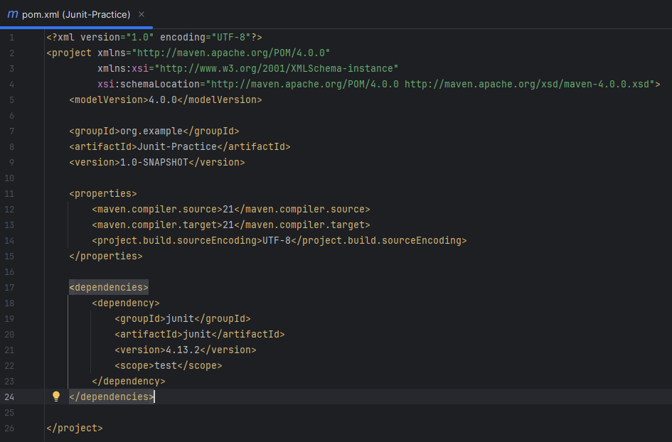

1. Create new test class

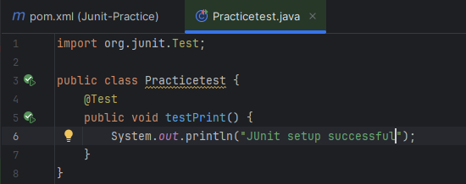

1. Run the test file

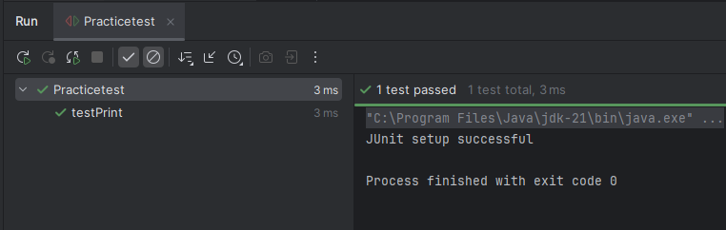

Exercise 3 : Assertions in Junit

We create a new test class “Assertionstest.java” and run the case

**SOLUTION :**

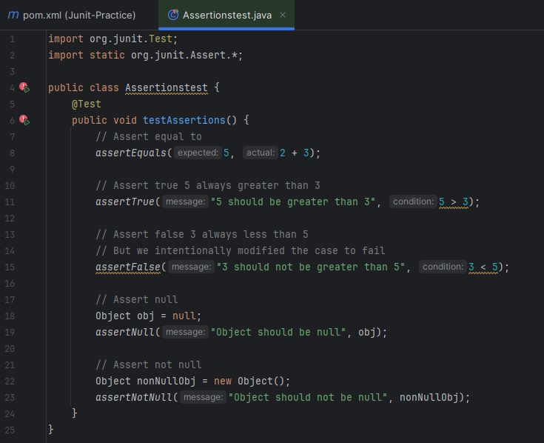

OUTPUT :

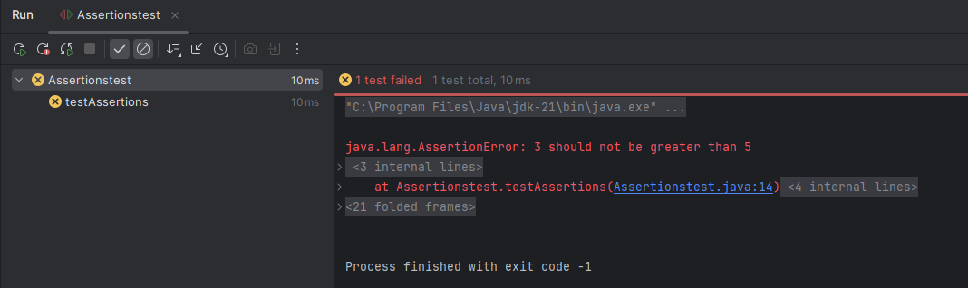

When we modify the test case to pass, here is how the output will be displayed

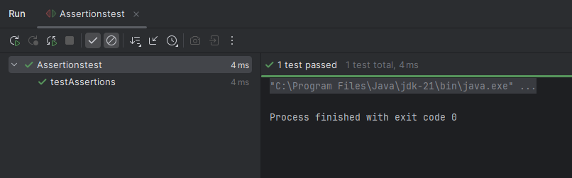

Exercise 4 : Arrange-Act-Assert (AAA) Pattern, Test Fixtures, Setup and Teardown Methods in JUnit

We create a java class file “Calculator.java” to test using AAA pattern

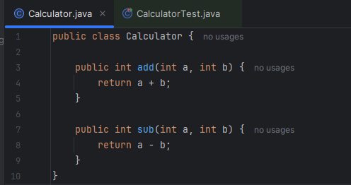

We create test class file “CalculatorTest.java” to implement AAA pattern

**SOLUTION :**

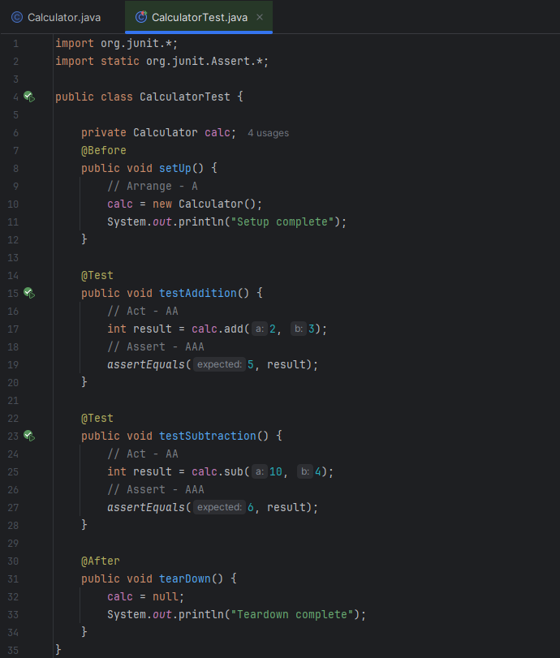

**OUTPUT :**

Everytime we run a test it is executed in the following order :  
1. @before

2. @test

3. @after

